Park Ridge-Niles
Community Consolidated School District 64
8182 Greendale Avenue
Niles, IL 60714

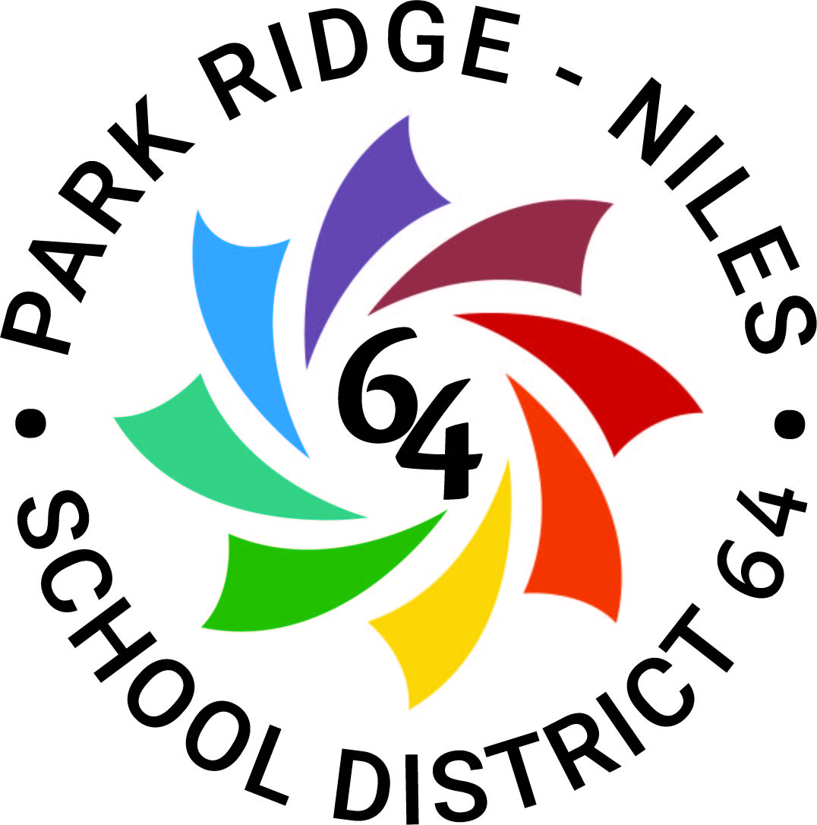

Request for Qualifications
For
Architect Services

Dr. Adam Parisi
Chief School Business Official
(847) 318-4324

- Introduction

The Board of Education for Park Ridge-Niles Community Consolidated School District No. 64 (“District 64”) is soliciting statements of interest from qualified firms to provide comprehensive architectural services, as per the Local Government Professional Services Selection Act (50 ILCS 510/0.01 et seq.), to assist District 64 in performing possible planning, remodeling, construction, life-health safety and special projects. The firm selected shall have the primary responsibility for execution of the planning, design construction documentation, and construction administration phases of a project.

This Request for Qualifications (“RFQ”) is not an invitation for bid: responses will be evaluated based on qualifications, ability of professional personnel, past record and experience, performance data on file, willingness to meet time requirements, location, workload of the firm, and insurance levels (the “Evaluation Qualifications”). There will be no public opening and reading of responses received by District 64 pursuant to this request.

District 64 consists of eight schools with one of the buildings also housing its District Offices. District 64 serves approximately 4,700 students, and the District 64 buildings consist of approximately 750,000 square feet.

Architectural firms responding to this request must submit their written response on or before Thursday, November 17, 2022, at 10:00 a.m. in a sealed envelope, with the name and address of the firm listed on the outside of the envelope, and including a name, phone number and email address of a contact at the firm, addressed to:

Dr. Adam Parisi
Chief School Business Official
Park Ridge-Niles Community Consolidated School District No. 64
8182 Greendale Avenue
Niles, IL 60714

Each respondent shall submit four (4) hard copies in an envelope of its response to this RFQ. No email of facsimile submissions should be accepted.

District 64 reserves the right to reject any or all proposals, or parts thereof, and to waive any or all technicalities. Omission of any information may be sufficient cause for rejection of a statement of interest.

Submittals should be prepared on standard 8-1/2 x 11 letter size paper, and shall be limited to sixty double-sided pages, exclusive of required attachments. Adherence to the maximum page criterion is critical; each page side with criteria information will be counted toward the maximum number of pages. Front and back covers, table of contents pages, and tabbed divider pages will not be counted if they do not contain submittal information.

Any responses to questions, or changes in this RFQ, shall be issued in writing as an addendum. Respondents must acknowledge addenda received as part of their submissions.

B. General Terms and Conditions

- All costs associated with developing or submitting a qualifications statement in response to this request, or to provide oral or written clarification of its response shall be borne by the respondent. District 64 assumes no responsibility for these costs. This RFQ does not commit District 64 to pay any costs incurred in preparation or submission of a response or in anticipation of a contract.
- This RFQ does not commit District 64 to enter into a contract. District 64 reserves the right to award one, more than one, or no contract(s) in response to this RFQ. District 64 reserves the right to terminate this RFQ, and reissue a subsequent solicitation, and/or remedy technical errors in the RFQ process.
- A contract, if awarded, will be awarded to the respondent(s) whose Evaluation Qualifications are deemed most advantageous to District 64, as determined by the selection committee and approved by the District 64 Board of Education.
- District 64 reserves the right to contact any respondent for clarifications and or interviews if such is deemed desirable by District 64.
- The purpose of this RFQ is to identify an experienced architectural services firm, or firms, with the best combination of qualifications based on the factors in this RFQ.
- Requests for site visits and introductory meetings will not be allowed.
- All respondents are prohibited from making any contact with District 64 Personnel, Board of Education members, the Superintendent or any other administrator or employee of District 64 regarding the RFQ, other than in the manner and to the person(s) designated herein.
- General Description scope of Services

- The selected architectural firm will become part of a project team consisting of members of District 64 and community stakeholders and to perform services as required.
- The Design Team may be requested to:
  - Attend meetings with District 64 administrative staff as necessary;
  - Attend District 64 Board of Education meetings as necessary;
  - Develop preliminary drafts of the project program for District 64 review and comment;
  - Consult with District 64 on budgetary and funding matters;
  - Consult with District 64 on project scheduling considerations; and
  - Consult with District 64 on general concepts of the project scope of work and project needs.
The firm's services and product provided shall conform to the Illinois State School Code and be in accordance with all federal, state and local laws, codes, ordinances, and regulations

- Responding Firm’s Specifics

Firms responding to this RFQ must submit their responses to the following items in the exact order listed below. Firms will be chosen based upon their responses to the questions below.

1. Name of firm, address, telephone number, fax number.

2. Name, title, phone, and fax numbers of contact person.

3. How long has your firm provided architectural services to Illinois public school clients?

4. Include a list of Illinois public school districts (not projects) where you have provided architectural services similar to those required by Park Ridge-Niles Community Consolidated School District 64.

5. Identify any legal proceeding (arbitration, mediation, or litigation) filed by an owner against your firm for any project for which you provided architectural services during the last five years. Include the name of the parties in the action, the caption of the matter, the year the action was filed, the relief sought and the resolution.

6. Provide an organizational description of your in-house design team including architects, engineers, and other pertinent staff members. List all key members of the team you propose will perform work for this project. Include resumes for all team members and their role in recent educational projects. Further, please provide a description of any awards, special recognitions and certifications that your firm and or members thereof have received in the past five years.

- Provide an organizational description of all outside consultants that will aid your firm while providing services to District 64, including the consultant’s in-house team and pertinent staff members. List all key members of the consultant’s team you propose will perform work for this project. Include resumes for all consultant team members and their role in recent educational projects.

- Describe your firm’s philosophy on how to address each of these common problem areas found in school construction:

a. Quality control
b. Change orders
c. Meeting timelines
d. Cost estimating
9. Describe your experience with “green” or sustainable design? Were any projects LEED certified? If so, what level?

- Summarize the strengths of your organization that would benefit District 64 during future projects.

- Based on your firm’s current, and foreseeable, workload, describe how your firm will be able to timely meet the demands of District 64.

- Provide a current copy of a Certificate of Insurance evidencing your current limits (both per claim/per occurrence and in the aggregate) of the following types of insurance: (i) commercial general liability insurance; (ii) professional liability insurance; (iii) excess or umbrella insurance; (iv) automobile liability insurance; and (v) worker’s compensation insurance and employer’s liability insurance. The successful firm will be expected to have the Board of Education, its individual Board members, officers, directors, employees and agents named as additional insureds on all insurance policies identified above, except for worker’s compensation insurance and professional liability insurance. Confirm your firm will agree to the above requirement.

E. Project Approach

Provide a brief explanation of the following:

- The methodology that your firm would use in conducting the project from inception to acceptance. This should include strategies for collaboration, communication and community building. If your methodology utilizes any specialized software packages and computerized systems, please provide an adequate description and summary of capabilities.

- The firm’s ability / experience to work in Park Ridge and Niles. In your response, describe how your firm plans to respond when District 64 has immediate needs that require on-site attention.

- Your approach to project scheduling and cost estimating within the environment of the educational sector.

- The process your firm utilizes to investigate bidders to ensure that they are qualified and equipped to satisfactorily complete a project.

F. References

Provide a minimum of three references for architectural services performed on educational facilities in Illinois in the last five years. Include the name of the reference, the address, name of the educational institution and provide a summary of the services provided to the reference.

G. Questions and Clarifications

Any questions or requests for clarifications to this RFQ must be submitted in writing to:

Dr. Adam Parisi
Chief School Business Official
Park Ridge-Niles Community Consolidated School District No. 64
8182 Greendale Avenue
Niles, IL 60714
aparisi@d64.org

Questions or requests for clarification shall be submitted no later than Friday, November 11th, 2022 at 12:00 noon. Questions or requests for clarification received after this date and time will not be considered. Responses to questions or requests for clarification shall be issued by District 64 in writing to all firms that have provided their contact information to Dr. Parisi. Oral statements shall not be binding upon District 64.

All firms intending to submit a response to this RFQ shall provide their email contact information to Dr. Parisi to ensure that they are provided with any addenda, modifications and clarifications related to this RFQ. It is the respondent’s responsibility to ensure that it has received all communications and addenda issued related to this RFQ.

1074168_2.docx

